**UGANDA BOSTON COMMUNITY ASSOCIATION**

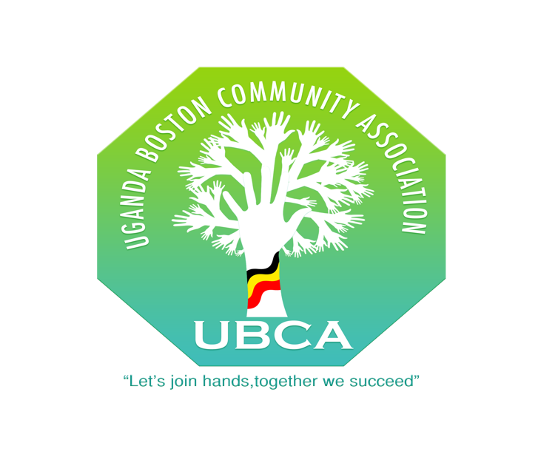

**COVID-19 TASKFORCE COMMITTEE**

**FINAL REPORT 2020**

**DECEMBER 2020**

**Introduction (Ennyanjula)**

* In **April 2020**, the Uganda Boston Community Association to set up a Task Force committee to seek ways to address emergency needs in our community during the pandemic.

This report provides a summary of what has been accomplished since the Taskforce was set up in April.

**Donations and Contributions**

* This effort was initially supported by donations from the Ugandan community in Boston, friends, and well-wishers.
* These donations included $8,199 in cash, food, meals, essential household supplies, gloves, masks (PPE).
* These items and cash were donated by a total of 112 donors including,
* individuals, places of worship, non-profit organizations, and various businesses within the Ugandan community in Massachusetts.
* Then in July we applied for and received a $25,000 grant from The Boston Foundation and later a $5,000 grant from the Weston Cares Foundation.
* In total we received $38,199 in cash donations and grants.

**FAMILIES ASSISTED**

* A total of 121 families have been provided assistance. These families included a total of 253 individuals of which 86 were children and 14 elderly.
* 54 Families (or 44%) had multiple family members, 42 families (or 35%) were women living alone and 25 families (or 20%) were men living alone.

**REASON FOR SEEKING ASSISTANCE**

* Of the 121 families assisted 58 families (or 48%) indicated unemployment or reduced work hours as the reason for requesting assistance.
* 49 families (or 40%) indicated at least 1 member of the family being COVID-19 positive or having some other illness or disability.
* 14 families (or 12%) were elderly.

**Type of Assistance**

* 96 of families (or 79%) were provided cash assistance to help pay for food and utilities);
* 12 families (or 10%) received noncash assistance in the form of items such as hot meals, matooke (myeela), beans, canned food, cereal, milk, orange juice, home remedy juice drink mix to help improve immunity, household supplies, gloves, masks.
* 10 Families (or 9%) were provided cash assistance for rent.
* 3 families (or 2%) were provided counseling services.

**Challenges**

* Due to lack of resources, we could not assist many families with rent. This policy was in part guided by the fact that Landlords were not evicting tenants during the Pandemic shutdown, plus we also wanted to use funds available to assist as many people as possible.
* During the initial months of the lockdown there were challenges in organizing deliveries to COVID positive individuals isolating in their homes especially initially when we had no masks and there was uncertainty about the Corona Virus.
* In one instance we faced the challenge of having to relocate a COVID positive individual to a location where they could self-isolate without jeopardizing the health of roommates.
* Many people that were served, especially those that live alone needed counseling, prayer, and moral support.
* Need for more volunteers to participate in these efforts.

**Recommendations**

1. Find ways to better prepare for emergencies in our community.
2. Encourage community leaders to ask their members to volunteer in community efforts such as this.
3. Establish a database of volunteers and sponsors.
4. Seek additional partnerships/sources of funding, state or federal or private foundations.